Employment Services
We provide comprehensive employment services to students in the Computer Technician Training and the PRO Customer Service & Administrative Training
Services include:
- Realistic goal setting
- Job placement support
- Employment counseling
- Soft skills coaching
- Resume & cover letter development
- Online job search assistance
- Career assessment
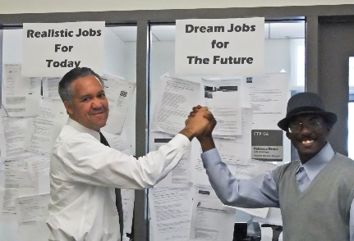

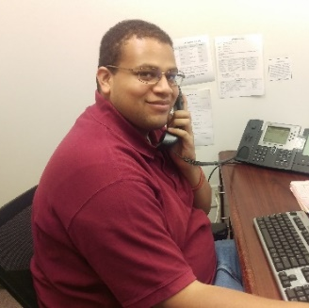

(510) 849-2911

“6 months ago I never thought I would work again due to age bias and my lack of cutting edge computer skills. But thanks to all the instructors at CTP that feeling of helplessness has changed to empowerment.”
-Berkeley DOR consumer

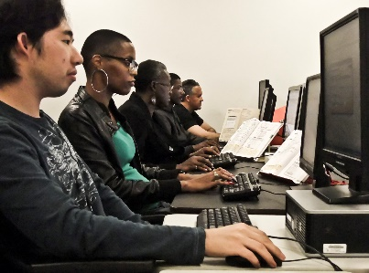

“The training has helped me to want to open up to more learning and it has helped me with my confidence.”
-Oakland DOR consumer

"This school here is where I got another chance at a career. The staff helped me to hone my skills, they got me a great internship at a local municipality, and the rest is personal determination.”
-Antioch DOR consumer

Contact
Information

Ed Roberts Campus
3075 Adeline Street, Suite 240
Berkeley, CA 94703

(510) 849-2911
Fax: (510) 849-2968

Website: www.ctpberk.org
Email: info@ctpberk.org
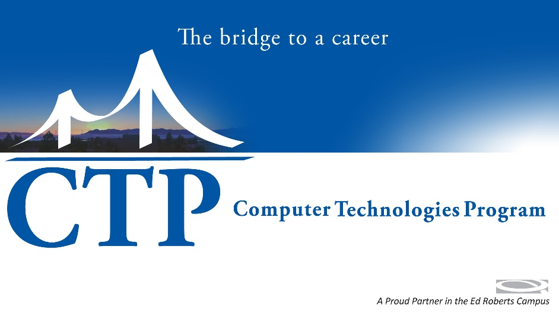

Computer Technologies Program
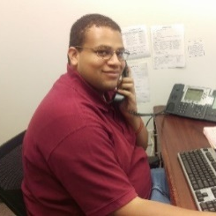
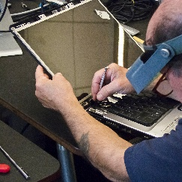

Tech Jobs
Admin Jobs

E x p a n d i n g

employment opportunities
for
people with disabilities
since 1974

www.ctpberk.org

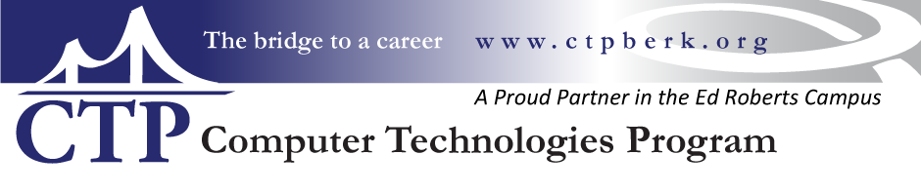

Computer Essentials
A great introductory class for beginners and those who have out-of-date computer experience. This class focuses on the use of Windows, document creation, emailing & attachments, file & folder management as well as internet search and using online maps.
Computer Essentials is 3 weeks long

Computer Skills Bootcamp
Bootcamp focuses on developing student’s readiness for computer based jobs and advanced training. This is a project based class which covers efficient Windows usage, Google Apps, career research and personalized guided electives. A major focus is placed on professionalism including attendance and professional accountability.
Bootcamp is 4 weeks long
Class Projects
- Power Point presentation
- Career Research Packet
- Resume

PRO Customer Service & Administrative Training
PRO graduates are suited to a wide variety of entry-level jobs such as customer service, administrative roles and retail sales positions such as: cashier, office clerk, receptionist and telephone & customer service representative.
Training includes

- Microsoft Office: Word, Excel & Power Point: Creating documents and managing files
- Office phone skills: Multi-line phone systems & phone etiquette
- Customer Service: Professionally managing customers and problem solving
- Office Machines: Copiers, faxing and scanners
- Clerical Tasks: Filing, data entry
- Point of sales skills: Cashiering and customer interaction
- Food Handling & Safety certificate available
- Customer Service certificate available
PRO is 3 months long

Computer Technician Training
CTT graduates are prepared for diverse employment opportunities that range from technical support specialist, customer service representatives, desktop/deskside support, technical sales, and network/server administration.
Training includes

- CompTIA A+ Certification exam objectives
- Network Troubleshooting
- Operating Systems maintenance
- Hardware Repair
- Network security

Computer Technician Training is 3 months of on-site technical training followed by a 160 hour externship with a local Bay Area company.
